

**Job Description**



| **POSITION:** | **Property Services Assistant** |
| --- | --- |
| **REPORTS TO:** | Property Supervisor |
| **DEPARTMENT:** | Property Services |
| **DATE APPROVED:** | February 2025 |

**Position Purpose**

The Property Services Assistant position plays a vital role in the upkeep and maintenance of the Belmont Christian College premises and property in coordination with the property maintenance team. The Property Services Assistant position is responsible for ensuring the school’s facilities remain in excellent condition through routine and responsive maintenance. safely and efficiently.

**The role supports and fosters high-quality Christian education by leveraging technology and ensuring technology is stable, secure and sustainable for the students, staff and our community.**

**Organisation Environment**

Belmont Christian College operates within a unique and spiritually nurturing environment

that combines strong academic and wellbeing foundations with Christian values. The College is a leading Christian P-12 school in the Newcastle region that has experienced

growth in recent years with over 900 students and 150 members of staff.

**The Team**

The BCC property and maintenance team provide hands-on support to ensure the property and grounds of BCC are in a good condition at all times and maintained at a high standard, under the instruction and guidance of the Property supervisor.

The key duties of the **Property Services Assistant** position include assisting with scheduled and responsive repairs, setting up and packing down events, and overseeing the upkeep and procurement of tools and supplies, minor repairs on the College property.

**Key Accountabilities**

| **Area of Accountability** | **Major Activities** | **Performance Indicators** |
| --- | --- | --- |
| Christian Leadership | Demonstrate a Christ-like example in the College ensuring that:   * All activities are undertaken with a strong Christian commitment and focus. * Christian servant leadership is exercised with staff, students, parents, and the wider community. * Perform day-to-day duties prayerfully and consistent with a Biblical lifestyle with the aim of bringing glory to God. | **Strategies and actions** are aligned to the College’s vision and mission.  Conduct is aligned to behaviours outlined in the Statement of **Faith and Codes** of Conduct. |
| General Maintenance & Repairs | * Perform routine maintenance and minor repairs on school buildings, classrooms, and facilities. * Inspect and repair doors, windows, locks, and fixtures, etc. * Patch and paint walls, ceilings, and surfaces as needed. * Fix minor plumbing issues, such as leaking taps, blocked drains, and running toilets. * Maintain and repair school furniture, including desks, chairs, and shelves. | * Timely completion of scheduled maintenance tasks. * Minimal disruption to school activities due to maintenance work. * Repairs completed effectively and safely, meeting WHS standards. * Positive feedback from staff and students regarding maintenance services. |
| Grounds & Outdoor Maintenance | * Maintain school grounds, ensuring they are clean, safe, and presentable. * Conduct landscaping tasks such as mowing, trimming hedges, pruning trees, and removing weeds. * Maintain outdoor play equipment, ensuring safety and proper functionality. * Repair and maintain pathways, driveways, and external structures. * Clean and maintain gutters, drains, and downpipes. * Assist with setting up and dismantling temporary structures for school events. | * Grounds and outdoor areas are consistently well-maintained. * Landscaping tasks completed as per the maintenance schedule. * Play equipment and external structures are in good condition and safe for use. * Gutter and drainage maintenance prevents water damage or blockages. |
| Safety & Compliance | * Conduct routine safety checks and inspections on school property. * Ensure all maintenance tasks comply with WHS (Work Health and Safety) regulations. * Identify and report hazards, undertaking necessary repairs or escalating issues to management. * Secure hazardous tools and materials, ensuring safe storage. | * All tasks to comply with WHS standards. * No safety hazards due to negligence or poor maintenance. * Emergency equipment is functional. * Prompt reporting and resolution of potential hazards. |
| Equipment & Resource Management | * Maintain tools, machinery, and school maintenance equipment in good working order. * Order and restock maintenance supplies as needed. * Maintain an inventory of maintenance tools and materials. * Liaise with external contractors for major repairs or specialist maintenance tasks. | * Tools and equipment are in good working condition and safely stored. * Adequate stock of maintenance supplies to avoid delays. * Accurate and up-to-date inventory records. * Effective coordination with external contractors, ensuring timely service delivery. |
| Event & Logistics Support | * Assist with setting up and dismantling equipment for school events, assemblies, and exams. * Move and arrange furniture as needed for classroom or office changes. * Support staff with basic technical issues, such as assembling or fixing furniture. | * Event setups completed accurately and on time. * Efficient and safe movement of furniture and equipment. * Staff supported effectively with minimal disruptions |
| Emergency & Ad-Hoc Repairs | * Respond promptly to urgent maintenance issues. * Address emergency repairs, such as leaks, or broken locks. * Ensure a quick and efficient resolution to any unexpected maintenance problems. | * Rapid response to emergency repair requests. * Effective troubleshooting and resolution of urgent issues. * No prolonged downtime of essential school facilities. |

**Key Communications**

**Internal communications:**

* **Property Supervisor** to get instructions and feedback on immediate action items, recurring or adhoc tasks.
* **Extended maintenance team** to collaborate with and bring closure to the open maintenance support and service.
* **Deputy Principal, Teachers, Heads of School and IT Manager** on receiving the maintenance requests, apart from the service log of the tickets.

**External Communications:**

* Maintenance equipment service providers.

**Challenges**

* Ensuring consistency of addressing the maintenance tasks in a prompt and timely manner.
* Ability to prioritise and attend to routine and adhoc service requests, efficiently.

**Knowledge, Skills and Experience**

1. It is an inherent requirement of the role that the incumbent have a personal relationship with Jesus Christ, actively attend their local Church, and willingly support the vision and practice of the College as stated in:
   1. the College Statement of Faith,
   2. the Staff Pledge that is recited annually at the Staff Commissioning Service, and
   3. the College Codes of Conduct.
2. Equivalent experience in maintenance/Property Services roles.
3. Basic knowledge of plumbing, carpentry, and general repair work.
4. WHS training or awareness of safety regulations in a school environment.
5. Current Working with Children Check.
6. Requirement (preferably) of MR licence for bus driving.
7. Demonstrated experience in the following competencies:
   1. **Task completion and efficiency-**Abilityto completethe maintenance tasks as required.
   2. **Problem-Solving and initiative** – Proactively identifying maintenance issues, troubleshooting problems, and implementing effective solutions in a timely manner, apart from taking instructions from the Property Supervisor.
   3. **Time Management and adaptability** – Ability to prioritise tasks, manage workload efficiently, and respond promptly to urgent maintenance needs while supporting school operations.
   4. **Teamwork and communication** – Strong interpersonal skills to collaborate effectively with staff, contractors, and the broader school community, ensuring maintenance tasks and event setups

**Organisation Chart**

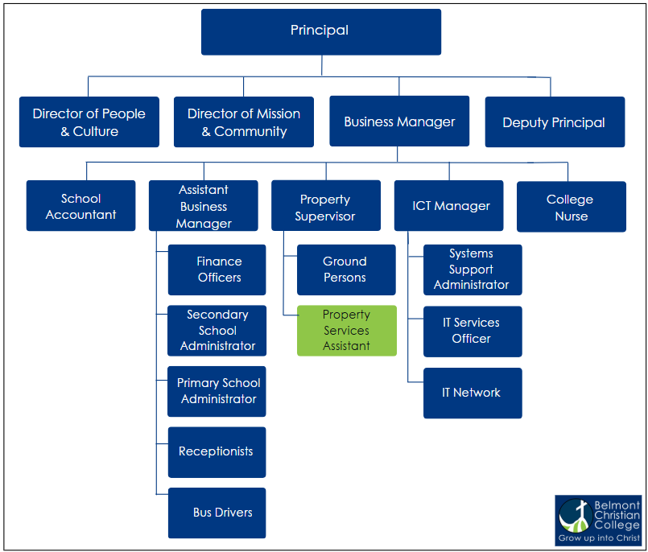

**Selection Criteria**

1. It is an inherent requirement of the role that the incumbent have a personal relationship with Jesus Christ, actively attend their local Church, and willingly support the vision of the College.
2. Knowledge of and a deep commitment to child safety in an education setting.
3. Current Working with Children Check
4. Relevant trade qualification or equivalent experience in maintenance/Property Services roles.
5. Basic knowledge of plumbing, carpentry, and general repair work.
6. WHS training or awareness of safety regulations in a school environment.
7. Demonstrated experience in the following competencies:
   1. Task completion and efficiency
   2. Problem-Solving and initiative
   3. Time Management and adaptability
   4. Teamwork and communication

**Signature**

Incumbent name Incumbent signature Date